**ASSIGNMENT II**

1) Find the minimum vertex cover for the following undirected graph by

**a) Approximation Algorithm**

**b) Greedy Approach**

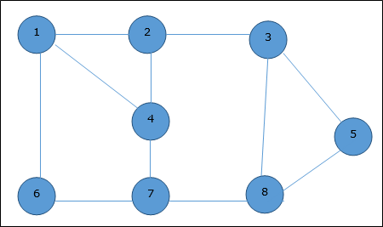

2) **Given :**Input String be **“ADBDA”**and Pattern to be searched be**“BD”**

Let **‘d’** be the length of the input string and **‘m’** be length of the pattern to be searched

Let the prime number be **q = 11** and hash function is given by ,

**h = dm-1 mod q**

Check whether the pattern exists in the given input string or not by Rabin carp method

3) a. Find the max clique of this graph? To which class the clique problem belongs to? Justify it.

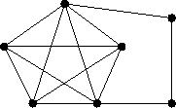

b. Given CNF, (X+Y+Z) (X+Y+Z') (X+Y'+Z)

(a) Is the above CNF satisfiable? If yes, give an instance of satisfiability.